## RabbitMQ - PZF.PendingSmRequests

[image](https://gitlab.zap.intra/integracao/kb/uploads/b290a707859df4211a539eff4eafaf01/image.png)Caso não regularize

[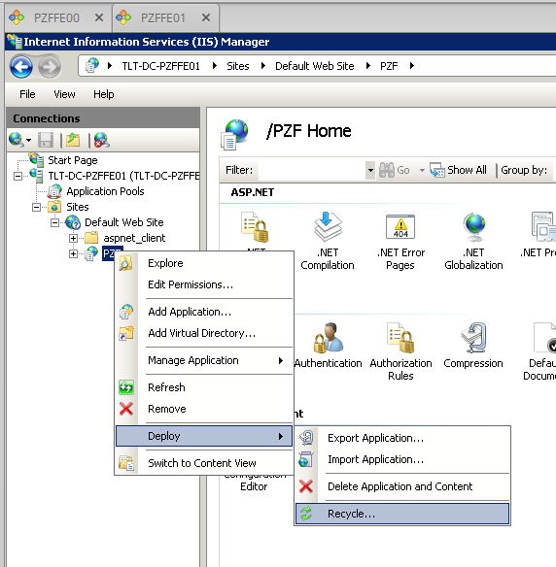](https://gitlab.zap.intra/integracao/kb/uploads/847243eec7a162b41e43276bf7f8df00/image.png) [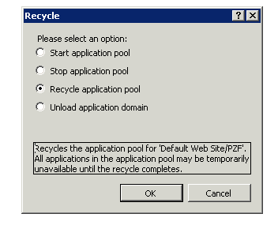](https://gitlab.zap.intra/integracao/kb/uploads/917056d193b8056ba92c804e4eeee50c/image.png)

1. Fazer recycle das app pools no IIS dos PZFFE00 e/ou PZFFE01.
2. Aguardar 1 a 2min e reagendar o check.